API Rate Limiter

- System and its uses:
Rate Limiting is a process that is used to define the rate and speed at which consumers can access APIs.

Throttling is the process of controlling the usage of the APIs by customers during a given period. Throttling can be defined at the application level and/or API level. When a throttle limit is crossed, the server returns HTTP status “429 - Too many requests". Here are the three famous throttling types that are used by different services:
  - Hard Throttling: The number of API requests cannot exceed the throttle limit.
  - Soft Throttling: In this type, we can set the API request limit to exceed a certain percentage. For example, if we have rate-limit of 100 messages a minute and 10% exceed-limit, our rate limiter will allow up to 110 messages per minute.
  - Elastic or Dynamic Throttling: Under Elastic throttling, the number of requests can go beyond the threshold if the system has some resources available. For example, if a user is allowed only 100 messages a minute, we can let the user send more than 100 messages a minute when there are free resources available in the system.

Rate Limiter will be responsible for deciding which request will be served by the API servers and which request will be declined. Once a new request arrives, the Web Server first asks the Rate Limiter to decide if it will be served or throttled. If the request is not throttled, then it’ll be passed to the API servers.

A rate limiter limits the number of events an entity (user, device, IP, etc.) can perform in a particular time window. For example:
  - A user can send only one message per second.
  - A user is allowed only three failed credit card transactions per day.
  - A single IP can only create twenty accounts per day.
In general, a rate limiter caps how many requests a sender can issue in a specific time window. It then blocks requests once the cap is reached. Some APIs may have more than one rate limits such as a user may not be able to create more than three short URLs per minute in addition to 100 short URLs per hour.
The use of this service can be understood with the example that imagine we have a service which is receiving a huge number of requests, but it can only serve a limited number of requests per second. To handle this problem we would need some kind of throttling or rate limiting mechanism that would allow only a certain number of requests so our service can respond to all of them.

Why do we need API rate limiting?
Rate Limiting helps to protect services against abusive behaviors targeting the application layer like Denial-of-service (DOS) attacks, brute-force password attempts, brute-force credit card transactions, etc. These attacks are usually a barrage of HTTP/S requests which may look like they are coming from real users, but are typically generated by machines (or bots). As a result, these attacks are often harder to detect and can easily bring down a service, application, or an API.
Rate limiting is also used to prevent revenue loss, to reduce infrastructure costs, to stop spam, and to stop online harassment.
Following is a list of scenarios that can benefit from Rate limiting by making a service (or API) more reliable:
Misbehaving clients/scripts: Either intentionally or unintentionally, some entities can overwhelm a service by sending a large number of requests. Another scenario could be when a user is sending a lot of lower-priority requests and we want to make sure that it doesn’t affect the high-priority traffic. For example, users sending a high volume of requests for analytics data should not be allowed to hamper critical transactions for other users.
Security: By limiting the number of the second-factor attempts (in 2-factor auth) that the users are allowed to perform, for example, the number of times they’re allowed to try with a wrong password.
To prevent abusive behavior and bad design practices: Without API limits, developers of client applications would use sloppy development tactics, for example, requesting the same information over and over again.
To keep costs and resource usage under control: Services are generally designed for normal input behavior, for example, a user writing a single post in a minute. Computers could easily push thousands/second through an API. Rate limiter enables controls on service APIs.
Revenue: Certain services might want to limit operations based on the tier of their customer’s service and thus create a revenue model based on rate limiting. There could be default limits for all the APIs a service offers. To go beyond that, the user has to buy higher limits.
To eliminate spikiness in traffic: Make sure the service stays up for everyone else.

Should we rate limit by IP or by user?
Let’s discuss the pros and cons of using each one of these schemes:
IP: In this scheme, we throttle requests per-IP; although it’s not optimal in terms of differentiating between ‘good’ and ‘bad’ actors, it’s still better than not have rate limiting at all. The biggest problem with IP based throttling is when multiple users share a single public IP like in an internet cafe or smartphone users that are using the same gateway. One bad user can cause throttling to other users. Another issue could arise while caching IP-based limits, as there are a huge number of IPv6 addresses available to a hacker from even one computer, it’s trivial to make a server run out of memory tracking IPv6 addresses!
User: Rate limiting can be done on APIs after user authentication. Once authenticated, the user will be provided with a token which the user will pass with each request. This will ensure that we will rate limit against a particular API that has a valid authentication token. But what if we have to rate limit on the login API itself? The weakness of this rate-limiting would be that a hacker can perform a denial of service attack against a user by entering wrong credentials up to the limit; after that the actual user will not be able to log-in.
How about if we combine the above two schemes? Hybrid: A right approach could be to do both per-IP and per-user rate limiting, as they both have weaknesses when implemented alone. So APIs which could be accessed without authentication could be throttled on per-IP basis and APIs which could only be accessed after authentication could be throttled on user basis.

- Goals and Requirements of the system:
  - functional requirements,
    - Limit the number of requests an entity can send to an API within a time window, e.g., 15 requests per second.
    - The APIs are accessible through a cluster, so the rate limit should be considered across different servers. The user should get an error message whenever the defined threshold is crossed within a single server or across a combination of servers.
  - non-functional requirements and
    - The system should be highly available. The rate limiter should always work since it protects our service from external attacks.
    - Our rate limiter should not introduce substantial latencies affecting the user experience.
  - extended requirements.
    - Analytics allowed by clients should be recorded.
- Workflow:
Following will be the typical API Rate limiter workflow:
  - Request will come to the web server.
  - The web server either before the authentication or after the authentication ask from the API Rate limiter service that whether the use of this API for this client is permitted at this moment or not.
  - If the API Rate limiter service replies in true then the request is sent to the application service and if it replies in false then the server returns HTTP status “429 - Too many requests" to the client.
- Nature of business:
- Type of users:
  - Admin user,
The informations extracted from analytics data should be provided to the admin user on the dashboard and he should be able to change the settings and configuration of the site.
- Some Design Considerations,
- UI,
N/A
- System APIs,
  - system APIs,
boolean isPermitted(apiId, userId);
- Algorithm,

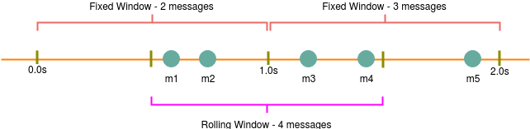
Fixed Window Algorithm: In this algorithm, the time window is considered from the start of the time-unit to the end of the time-unit. For example, a period would be considered 0-60 seconds for a minute irrespective of the time frame at which the API request has been made. In the diagram below, there are two messages between 0-1 second and three messages between 1-2 seconds. If we have a rate limiting of two messages a second, this algorithm will throttle only ‘m5’.
Sliding Window Algorithm: In this algorithm, the time window is considered from the fraction of the time at which the request is made plus the time window length. For example, if there are two messages sent at the 300th millisecond and 400th millisecond of a second, we’ll count them as two messages from the 300th millisecond of that second up to the 300th millisecond of next second. In the above diagram, keeping two messages a second, we’ll throttle ‘m3’ and ‘m4’.

DETAILED DISCUSSION ABOUT ALGORITHM:

Fixed Window algorithm:
Let’s take the example where we want to limit the number of requests per user. Under this scenario, for each unique user, we would keep a count representing how many requests the user has made and a timestamp when we started counting the requests. We can keep it in a hashtable, where the ‘key’ would be the ‘UserID’ and ‘value’ would be a structure containing an integer for the ‘Count’ and an integer for the Epoch time:
Let’s assume our rate limiter is allowing three requests per minute per user, so whenever a new request comes in, our rate limiter will perform the following steps:
  - If the ‘UserID’ is not present in the hash-table, insert it, set the ‘Count’ to 1, set ‘StartTime’ to the current time (normalized to a minute), and allow the request.
  - Otherwise, find the record of the ‘UserID’ and if CurrentTime – StartTime >= 1 min, set the ‘StartTime’ to the current time (normalized to a minute), ‘Count’ to 1, and allow the request.
  - If CurrentTime - StartTime <= 1 min and
    - If ‘Count < 3’, increment the Count and allow the request.
    - If ‘Count >= 3’, reject the request.

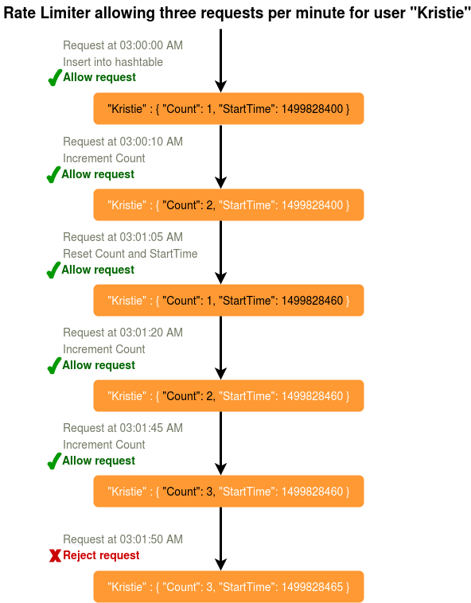

Problem with this fixed window algorithm?
More number of requests permissible in a particular time frame: This is a Fixed Window algorithm since we’re resetting the ‘StartTime’ at the end of every minute, which means it can potentially allow twice the number of requests per minute. Imagine if Kristie sends three requests at the last second of a minute, then she can immediately send three more requests at the very first second of the next minute, resulting in 6 requests in the span of two seconds.
Solution of this problem: The solution to this problem would be a sliding window algorithm.

How much memory would we need to store all of the user data?
Let’s assume the simple solution where we are keeping all of the data in a hash-table.
Let’s assume ‘UserID’ takes 8 bytes. Let’s also assume a 2 byte ‘Count’, which can count up to 65k, is sufficient for our use case. Epoch time will need 4 bytes. Hence, we need a total of 14 bytes to store a user’s data:
8 + 2 + 4 = 14 bytes
Let’s assume our hash-table has an overhead of 20 bytes for each record. If we need to track one million users at any time, the total memory we would need would be 32MB:
(14 + 20) bytes * 1 million => 34MB
If we assume that we would need a 4-byte number to lock each user’s record to resolve our atomicity problems, we would require a total 38MB memory.
This can easily fit on a single server; however we would not like to route all of our traffic through a single machine. Also, if we assume a rate limit of 10 requests per second, this would translate into 10 million QPS for our rate limiter! (Although memory requirement will be 38 MB only.) This would be too much for a single server. Practically, we can assume we would use a Redis or Memcached kind of a solution in a distributed setup. We’ll be storing all the data in the remote Redis servers and all the Rate Limiter servers will read (and update) these servers before serving or throttling any request.

Sliding Window algorithm:
We can maintain a sliding window if we can keep track of each request per user. We can store the timestamp of each request in a Redis Sorted Set in our ‘value’ field of hash-table.
Let’s assume our rate limiter is allowing three requests per minute per user, so, whenever a new request comes in, the Rate Limiter will perform following steps:
(i) Remove all the timestamps from the Sorted Set that are older than “CurrentTime - 1 minute”.
(ii) Count the total number of elements in the sorted set. Reject the request if this count is greater than or equal to our throttling limit of “3”.
(iii) Insert the current time in the sorted set and accept the request.

How much memory would we need to store all of the user data for sliding window?
Let’s assume ‘UserID’ takes 8 bytes. Each epoch time will require 4 bytes. Let’s suppose we need a rate limiting of 3 requests per minute. Let’s assume 20 bytes overhead for hash-table and 20 bytes overhead for the Sorted Set. So memory required for one user:
8 + (4 + 20 (sorted set overhead)) * 3 + 20 (hash-table overhead) = 100 Bytes
Here we are reserving 20 bytes overhead per element. In a sorted set, we can assume that we need at least two pointers to maintain order among elements — one pointer to the previous element and one to the next element. On a 64bit machine, each pointer will cost 8 bytes. So we will need 16 bytes for pointers. We added an extra word (4 bytes) for storing other overhead.

If we need to track one million users at any time, total memory we would need would be 100 MB:
100 Bytes * 1 million ~= 100 MB

If we need a rate limiting of 10 requests per second, then memory required for one user:
8 + (4 + 20 (sorted set overhead)) * 10 + 20 (hash-table overhead) = 268 Bytes
If we need to track one million users at any time, total hits on the server will be 10 million QPS and total memory we would need would be 268 MB:
268 Bytes * 1 million ~= 268 MB

- Capacity Estimation and Constraints
We will apply 30 : 50 : 70 capacity model for bandwidth, memory and storage.
  - Estimate of number of users and their uses,
Suppose this rate limiter service is applied to a service which has 100 million users out of which 10 million users are active and those 10 million users send 50 requests daily on average.
  - Estimate of read and write ratio,
This service is read only.
  - Traffic estimates,
Total number of requests per day = 10 million * 50 = 500 million
Total number of requests per second ≈ 6 k requests per second.
  - Bandwidth estimates,
This service has just one API which has two parameters that is apiId and userId. Suppose apiId takes 4 bytes and userId takes 8 byets. So total amount of data coming to the server in each request will be 12 bytes. Total amount of data going out in response will be 1 byte (boolean only).
So total bandwidth used for each request = 13 bytes
So required bandwidth = (13 * 6000) bytes per second = 78 KB per second
Now, according to the 30% capacity model for bandwidth, the required bandwidth will be 260 KB.
  - Memory estimates,
It is done with algorithm.
  - Storage estimates,
It can be done with algorithm.
- Database design,
  - Important points about nature of data,
In sliding window algorithm, we need to store userId and timestamps of all user requests in particular time window.
  - Basic database schema,
This we can store with the following json data structure.
{userId, [“timestamp_1”, “timestamp_2”, “timestamp_3”]}
  - identify the relations,
Non-relational data.
  - What type of database should we use?
MongoDB.
- Technology stack,
- Basic system design,
Diagram
- Detailed Component design,
- Concurrency,
In a distributed environment, the “read-and-then-write” behavior can create a race condition. Imagine rate limit per minute is 3. If Kristie’s current ‘Count’ is “2” and that she issues two more requests. If two separate processes served each of these requests and concurrently read the Count before either of them updated it, each process would think that Kristie could have one more request and that she had not hit the rate limit.
Solution of this problem: If we are using Redis to store our key-value, one solution to resolve the atomicity problem is to use Redis lock for the duration of the read-update operation. This, however, would come at the expense of slowing down concurrent requests from the same user and introducing another layer of complexity. We can use Memcached, but it would have comparable complications.
If we are using a simple hash-table, we can have a custom implementation for ‘locking’ each record to solve our atomicity problems.
- Data Partitioning,
We can shard based on the ‘UserID’ to distribute the user’s data. If we want to have different throttling limits for different APIs, we can choose to shard per user per API. Take the example of URL Shortener; we can have different rate limiter for createURL() and deleteURL() APIs for each user or IP.
- Service Component Partitioning,
- Data replication,
Data can be replicated for fault tolerance.
- Data archiving,
- Cache,
  - How much cache should we use?
Our system can get huge benefits from caching recent active users. Application servers can quickly check if the cache has the desired record before hitting backend servers. Our rate limiter can significantly benefit from the Write-back cache by updating all counters and timestamps in cache in synchronized manner and in permanent storage in asynchronous manner. This way we can ensure minimum latency added to the user’s requests by the rate limiter. The reads can always hit the cache first; which will be extremely useful once the user has hit their maximum limit and the rate limiter will only be reading data without any updates.
  - Which cache eviction policy would best fit our needs?
Least Recently Used (LRU) can be a reasonable cache eviction policy for our system.
  - How can each cache replica be updated?
For fault tolerance and replication we should use Consistent Hashing with one master two slaves configuration.
- Fault Tolerance
Cache should have consistent hashing with data replication at at least two places.
- Where to add load balancers?
- Purging or DB cleanup,
- Data deduplication,
- Security,
- Optimizations on the client to improve user experience,
- User Persionalization,
- Deployment,
  - docker,
  - kubernete,
  - autoscaling,
  - all internal servers will be deployed on vpn,
- Analytics,
What type of analytics should be tracked and how that analytics will be used to extract informations?
By collecting and analyzing the analytics data, we can make the system more intelligent which can understand the pattern of rate limits of genuine user, and thus can detect any type of attack or abuse more intelligently.
- Advanced Issues,
- Monitoring: Having the ability to monitor our systems is crucial. We should constantly collect data to get an instant insight into how our system is doing. We can collect following metrics/counters to get an understanding of the performance of our service:
  - No. of hits per day,
  - No. of hits per second and what is the daily peak?
  - Amount of data coming in and going out per day,
  - Amount of data coming in and going out per second and what is the daily peak?
  - Average latency seen by the user,

By monitoring these counters, we will realize if we need more replication or load balancing or caching, etc.
Continue benchmarking and monitoring your system to address bottlenecks as they come up. Scaling is an iterative process.

- Follow up questions:

